TRAMPOLINE & DMT EQUIPMENT CHECKLIST
Required Equipment | Make/Type | Age
Minimum 4 Trampolines
(including frame pads, end-decks and end deck mats)
Gym Mats
(sufficient to cover the floor surrounding the trampolines plus an additional 10m beyond each end deck)
Minimum 1 Throw In Mat for every trampoline plus one for the Double Mini Trampoline
Double Mini Trampoline
(includes frame pads, run up and landing area)
Judges Platform
(raised 1m from ground level – must seat min 9 people)

TUMBLING EQUIPMENT CHECKLIST
Required Equipment | Make/Type | Age
TUMBLING STRIP:
26m long “A rod-style”
Top Strip = two layers of 2” padded foam carpet or
1 layer of 2” padded foam carpet and 1 ¼” carpet
Single Layer of Padded Floor Covering Along Both Sides of the length of the Tumbling Strip
LANDING ZONE:
(a single, specially constructed mat or several gymnastics landing mats firmly secured together – two 8” thick landing mats placed side to side is acceptable)
RUN-UP:
(11m long and equal to the height of the tumbling strip)
Beat-board (minimum 1)
Training Mat – (minimum 8” thick)
Supplementary Mat – (1 to 2” throw mat)

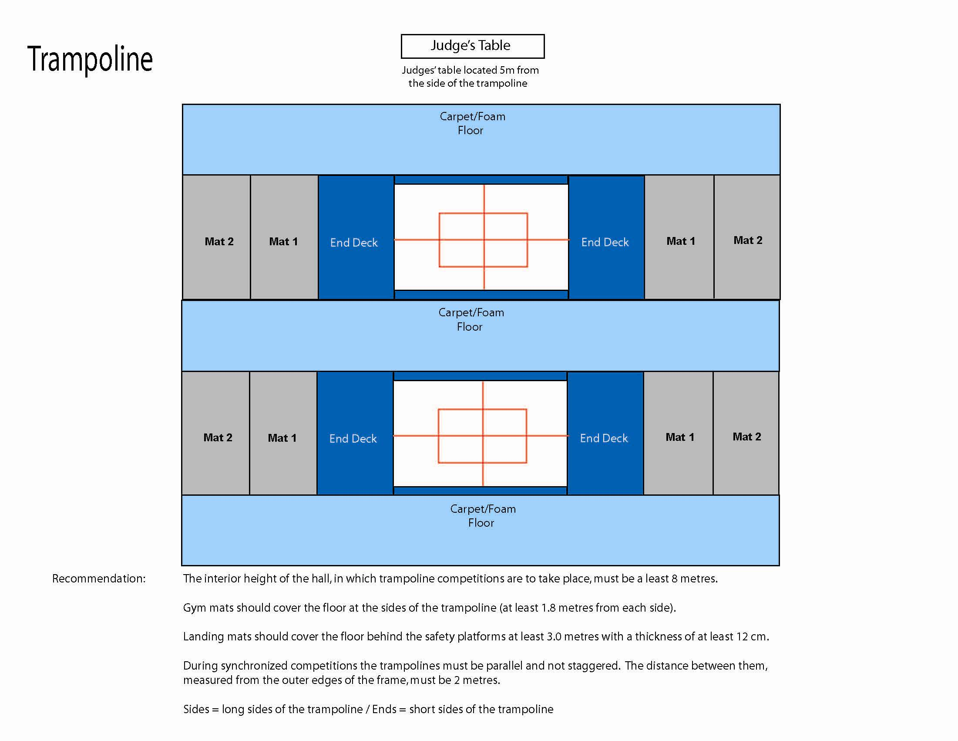
*Please refer to the FIG Apparatus Norms for full equipment regulations.

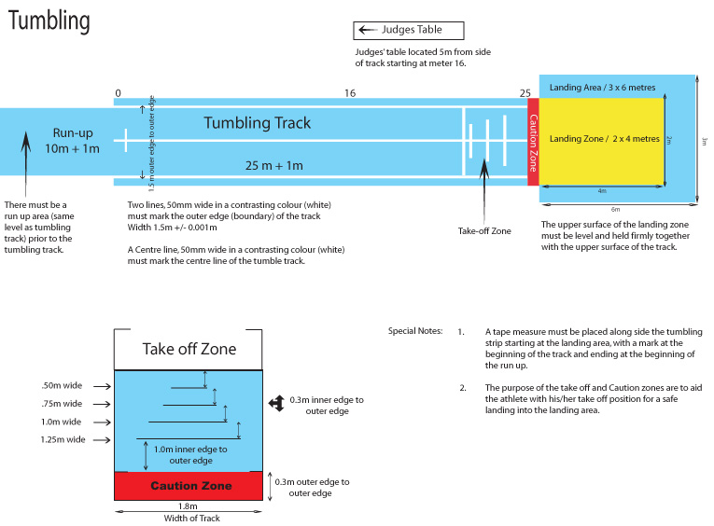
*Please refer to the FIG Apparatus Norms for full equipment regulations.

Double Mini Trampoline
Judges’ table located 5m from side of mini-tramp.
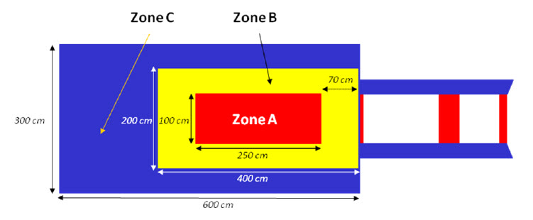
Judges’ Table
FIG Section 19.2

Recommendations: A tape measure must be placed along the run-up starting at the
frame of the mini-trampoline (0m).

A floor mat must be used on the run-up and must be:
Minimum Length 20 metres
Thickness 25 mm +/- 5mm

The interior height of the hall must be at least 6 metres

One safety mat with the minimum dimensions of 300 x 200 x 30 must be placed directly behind the landing area. This mat should be tethered / attached to the landing area.

Gym mats should cover the floor along the sides of the landing area.

*Please refer to the FIG Apparatus Norms for full equipment regulations.

